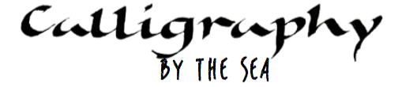
Booking Form

Name :

Email :

Telephone :

Address :

Please book me a place on:

Day course : 6 May 9 Jul 17 Sep
Weekend course : 17/18 June 23/24 Sep

If applicable : Please book accommodation at Trecastell Hotel :

16/17 June Single Double Twin Executive
23/24 Sept Single Double Twin Executive

My calligraphy experience is : Complete beginner
Or… tell me a little about your experience to help me tailor the course

I enclose a deposit cheque payable to Janet Smith for £50
Or
I have made a payment of £50 to J A Smith, First Direct, 40-47-86 34682769

The balance of ______________will be due 1 week before the course begins.

Other info (e.g. dietary requirements, extra nights’ accommodation):

janet@oakleafcalligraphy.co.uk
07723 035127
Janet Smith
Nant Y Môr
Bull Bay Road
Amlwch
LL68 9ED

